# **ECOMMERCE SEARCH FUNCTION**

# using System;

# public class Ecommerce

# {

# public static void Main()

# {

# string[] products = {

# "Headphones", "Smartphone", "Mouse", "Keyboard",

# "Laptop", "Monitor", "Power Bank", "Tablet"

# };

# Console.Write("Wish to Buy: ");

# string search = Console.ReadLine().ToLower();

# bool found = false;

# Console.WriteLine("Products Found:");

# foreach (string product in products)

# {

# if (product.ToLower().Contains(search))

# {

# Console.WriteLine(" " + product);

# found = true;

# }

# } if (!found)

# {

# Console.WriteLine("No products found.");

# }

# }

# OUTPUT

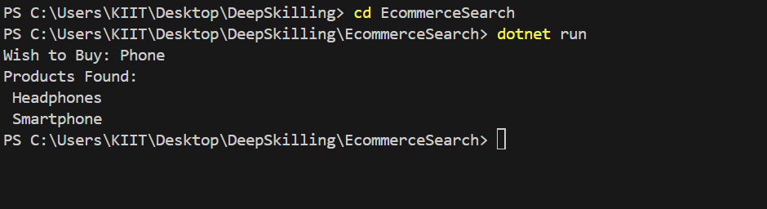

**FINANCIAL FORECASTING**

using System;

public class Forecasting

{ public static void Main()

{

Console.Write("For how many months do you want to calculate revenue: ");

int months = Convert.ToInt32(Console.ReadLine());

double[] revenue = new double[months];

double total = 0;

for (int i = 0; i < months; i++)

{

Console.Write($"Enter revenue for Month {i + 1}: ");

revenue[i] = Convert.ToDouble(Console.ReadLine());

total += revenue[i];

}

double average = total / months;

Console.WriteLine("\nFinancial Forecast Report");

Console.WriteLine("Total Revenue: " + total);

Console.WriteLine("Average Monthly Revenue: " + average);

}

}

**OUTPUT**

